A000-Eur-Constantinople-Cross-Pendant-Bifurcate-Bronze-500 CE

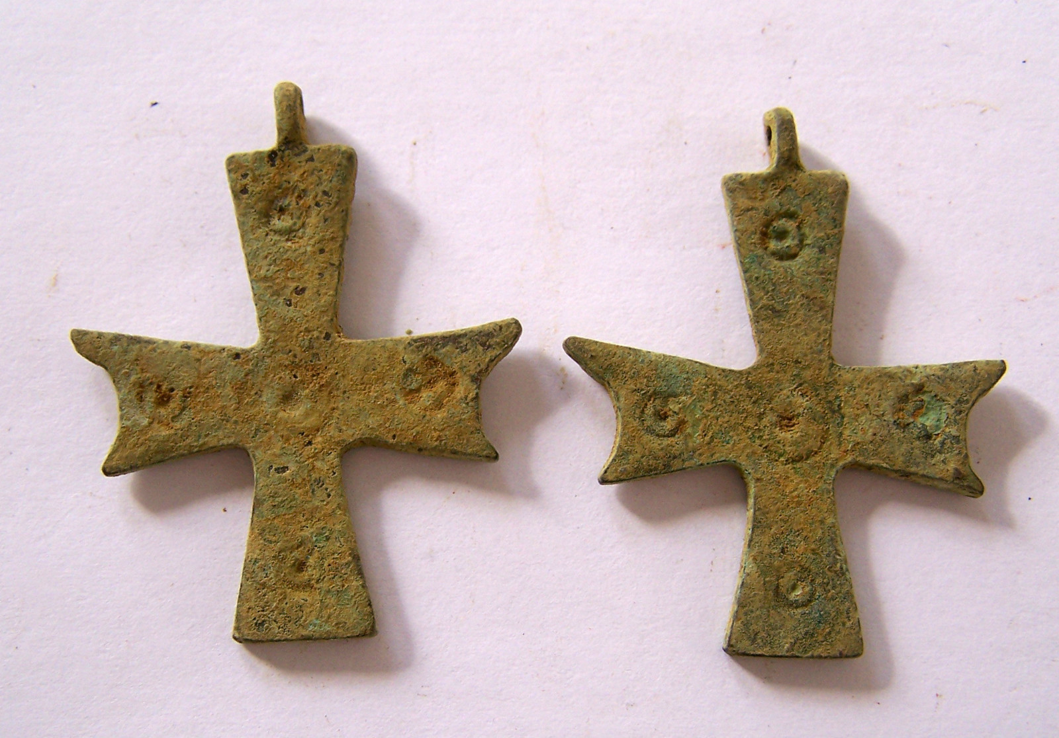

Figs. 1-2. Constantinople-Cross-Pendant-Bifurcate-Bronze-500 CE

**Case no.: 4**

**Accession Number:**

**Formal Label:** Constantinople-Cross-Pendant-Bifurcate-Bronze-500 CE **Display Description:**

This cross is based on a design in which the two ends of the horizontal arms of the cross are split or bifurcate. Each of the arms of the cross and their central intersection are marked with concentric circles.

**LC Classification:**

**Date or Time Horizon:**

**Geographical Area:**

**Map:**

**GPS coordinates:**

**Cultural Affiliation:**

**Media:**

**Dimensions:** 4.5 cm

**Weight:**

**Condition:**

**Provenance:**

**Discussion:**

**References:**